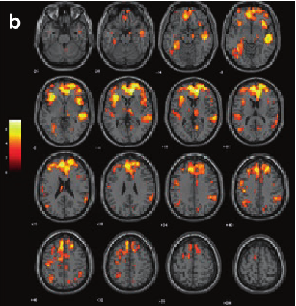

(Galderisi, 2019)

Automated Natural Language Processing and Schizophrenia:

The potential to create objective

diagnostic tools

Savita Mitra | XCMP-1560 | September 20, 2024

Table of Contents

Introduction 2

The need for early intervention and the dearth of objective diagnostic tools 2

Canadian statistics 2

Sex differences in onset, outcomes and symptoms variety 3

Onset and Outcome 3

Hope for the future 3

Patient Perspectives 1

Conclusion 1

References 1

# Introduction

Schizophrenia was first formally diagnosed as a mental illness in 1887. Dr. Emile Krapelin used the term *Dementia Praecox*, meaning early dementia (Erin L. George, n.d.). This was so the diagnosis would be distinct from later-onset senile dementia. The term schizophrenia was used in 1911 by Swiss psychiatrist Eugen Bleuler. His term used the Greek root word for split schizo and phren which is the Greek word for mind (Erin L. George, n.d.). This term was meant to convey the fragmented ‘disorganized’ thinking and avolition, symptoms which are generally first noticeable as the disease progresses.

While the diagnosis has been around 136 years and the actual term Schizophrenia for 112 years diagnosis of the disorder still relies on a clinician's best judgement and hopefully competence. The DSM5 recommends a clinician-rated formal neuropsychological assessment where a narrative is created using the patient’s own words (Association, 2013). Ideally, this assessment is supplemented with information from important individuals in the patient's life as well as previous medical records. However, “*brief assessment without formal neurophysiological assessment can provide useful information that can be sufficient for diagnostic purposes*.” Unsurprisingly clinician ratings based on the narrative assessment have an accuracy rating of 35% (Corcoran, 2020).

# The need for early intervention and the dearth of objective diagnostic tools

Advancements in diagnostic tools for schizophrenia began in the last decades of the 20th century. Manual language linguistic analysis of these narratives using focused criteria that weight illogical thoughts, poverty of content and referential cohesion errors provided a 71% accuracy rating (Corcoran, 2020). Again, manual language processing requires a highly trained individual with the time and resources to create a full assessment. Current healthcare resources do not allow for this level of time and money spent on individual assessments, especially in an emergency room. Automated natural language processing has the potential to offer a cost-effective highly accurate objective tool to augment the clinician's informal assessment. These solutions could significantly lessen health disparity while also providing excellent data that can also be used for further study (Argolo, 2020).

## Canadian statistics

About 1% of Canadians live with diagnosed schizophrenia. Alberta is slightly lower than the national average with 0.9% of Albertans living with diagnosed schizophrenia between 2016 and 2017, the most recent data available on the Stats Can Website (Canada, 2020). Canadians living with schizophrenia have an increased all-cause mortality rate which is 2.8 times higher than those without schizophrenia (Canada, 2020). Men make up approximately 56% of Canadians living with diagnosed schizophrenia.

## Sex differences in onset, outcomes and symptoms variety

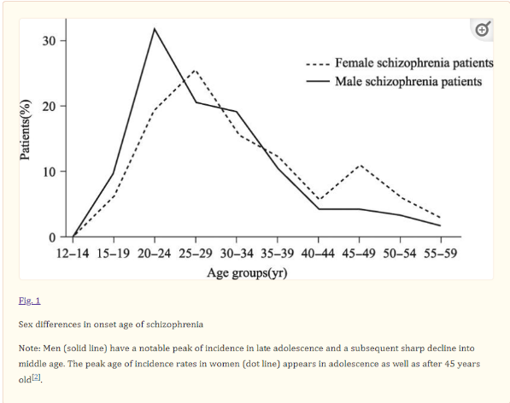

Figure Sex Differences in the onset age of schizophrenia ()

### Onset and Outcome

Roughly 30% of new cases were diagnosed between the ages of 20-34 years old. In this group, the rate of new cases was more than 2 x higher in men than women. Generally, men experience their first episode of schizophrenia earlier than women, with their single peak age between 21 and 25 years old. While women’s peak age is between 25 and 30 years old (Li, 2016).

Data shows that the earlier the onset of first schizophrenia the more severe the disease and the more treatment resistance. Especially if there is a delay of more than 6 months between onset and intensive treatment. In addition to differences in age of onset, there are also variations in initial symptoms. Outcomes for women and men reflect the difference in age of onset (Li, 2016).

# Hope for the future

As mentioned in the introduction there are no accepted biological validations or lab tests for diagnosis. The Schizophrenia Society of Canada goes on to add that “*the human suffering, family tragedies, and financial burdens caused by schizophrenia represent a tremendous challenge for the scientific community*” (Canada S. S., 2018). This lack of objective diagnostic tools is a hindrance to the wider adoption of current psychiatric best practices and lessening the stigma of mental health within Canadian society.

Automated natural language processing has the potential to provide a highly accurate objective diagnostic tool for schizophrenia that is cost-effective. There is an initial investment required to purchase the hardware and software to run the computational program and a microphone to record the narrative in the patient's own words.

There is still a lot of work to be done before a tool is ready for services. Until now most studies have been small proof of concept studies. Which given the stage the research is at makes sense. It has only been in the last year that artificial intelligence programs have become affordable and accessible to the wider public. These technological advances can be harnessed to train automated natural language processing software but will likely require government leadership. There is little money to be made in the treatment of schizophrenia so there is less investment from the private sector. However, governments stand to save immense amounts of money through fewer criminal justice interactions, emergency room visits, longer-term hospitalizations and other kinds of social service use.

Additionally, a multi-disciplinary research team consisting of psychosis/medical researchers, specifically trained linguists and computer science/machine learning research. A government program may have more success in recruiting professionals from those fields, in addition to providing funding. A large data set will be required, and copyright and privacy laws will have to be adhered to.

# Patient Perspectives

Patient cooperation during the treatment process can be difficult to attain. Treatment with anti-psychotic drugs can be unpleasant with well-documented side effects. These side effects can include weight gain which often puts patients at increased of diabetes, increased prolactin levels that can result in breast development for both sexes and lactation. Obstreperous is also a concern and a patient’s fertility can be affected. There is also an extreme stigma in wider society since most associate schizophrenia with the homeless and potentially dangerous due to high-profile bad outcomes like the incident on a bus in Manitoba in 2008 (BBC, 2017).

Since paranoia is a common symptom of schizophrenia individuals in the prodromal phase of psychosis or full-blown psychosis are unlikely to want to engage with recording technology. Many delusions also revolve around the implantation of surveillance equipment in patients' bodies, which further complicates matters. A study published in 2021 asked high-risk individuals if they would use one of two recording methods, a phone app manually recorded and a website where clips can be uploaded (Brederoo, 2021).

Table % of Respondents Recording Preferences

|  |  |  |  |
| --- | --- | --- | --- |
| Recording Method | Yes | Maybe | No |
| Phone App | 66% | 24% | 31% |
| Website | 21% | 29% | 30% |

# Conclusion

In the last 136 years, there have been few advances in the diagnosis of schizophrenia. Artificial intelligence and machine learning are providing hope that things may improve. Earlier and more accurate diagnosis benefits patients, clinicians and governments.

# References

Argolo, F. a. (2020). {Lowering costs for large-scale screening in psychosis: a systematic review and meta-analysis of performance and value of information for speech-based psychiatric evaluation. (S. Brasil, Ed.) *Brazilian Journal of Psychiatry, 42*(6), 673--686.

Association, A. P. (2013). *Diagnostic and statistical manual of mental disorders (.5th ed.).* doi:https://doi.org/10.1176/appi.books.9780890425596.CautionaryStatement

BBC. (2017). Canada man who beheaded bus passenger granted freedom. *BBC News*. Retrieved from https://www.bbc.com/news/world-us-canada-38945061

Brederoo, S. a. (2021). Implementation of automatic speech analysis for early detection of psychiatric symptoms: what do patients want? *Journal of psychiatric research, 142*, 299--301.

Canada, G. o. (2020). *Schizophrenia in Canada*. Retrieved 09 20, 2024, from Statistics Canada: https://www.canada.ca/en/public-health/services/publications/diseases-conditions/schizophrenia-canada.html

Canada, S. S. (2018). *About*. Retrieved 09 19, 2024, from Schizophrenia Society of Canada: https://schizophrenia.ca/about/

Corcoran, C. M. (2020). Using language processing and speech analysis for the identification of psychosis and other disorders. (Elsevier, Ed.) *Biological Psychiatry: Cognitive Neuroscience and Neuroimaging, 5*(8), 770--779.

Erin L. George, M. (n.d.). *Historical and Contemporary Understandings of Schizophrenia*. Retrieved 2024, from Mentalhelp.net.

Li, R. a. (2016). Why sex differences in schizophrenia? *Journal of translational neuroscience, 1*(1), 37. Retrieved from https://www.ncbi.nlm.nih.gov/pmc/articles/PMC5688947/